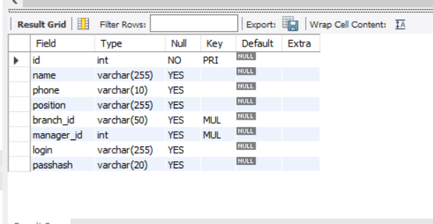

employees customers

branches loantypes

loan accounttypes

accounts overdraftlog

transactiontypes transactions

failedtransactionlog